Find the Way

Problem Description
In a directed graph G, each edge has a length of 1. Now, given a starting point and an ending point, find a path from the starting point to the ending point in the graph that satisfies the following conditions:

1. The outgoing edges of all points on the path point to points that are directly or indirectly connected to the endpoint.
2. Make the path shortest while Condition 1 is satisfied.

Note: There may be multiple edges and self-loops in graph G, and the problem guarantees that there is no outgoing edge at the end.

Please output the length of the qualified path.

Input
The first line has two integers n and m separated by a space, indicating that the graph has n points and m edges.

The next m lines each have 2 integers x, and y, separated by a space, indicating that there is an edge from point x to point y.

The last line has two integers s, t, separated by a space, indicating that the starting point is s and the ending point is t.

Output
The output is one line and contains an integer indicating the length of the shortest path that satisfies the description of the question. If such a path does not exist, output -1.

Sample Input 1
3 2
1 2
2 1
1 3

Sample Output 1
-1

Sample Input 2
6 6
1 2
1 3
2 6
2 5
4 5
3 4
1 5

Sample Output 2
3

Hint
Explanation 1:
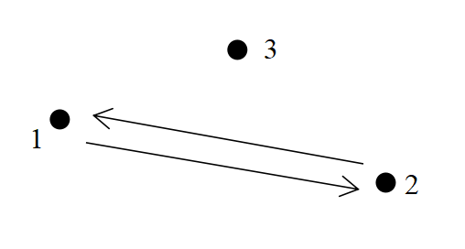
As shown in the image above, arrows indicate directed roads and dots indicate cities. Starting point 1 is not connected to ending point 3, so a path satisfying the description does not exist, so -1 is the output.

Explanation 2:
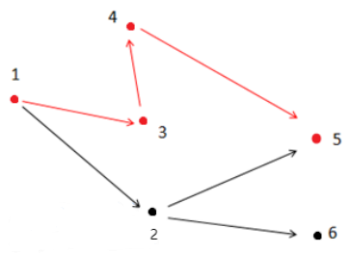
As shown in the figure above, the path that satisfies the condition is 1 → 3 → 4 → 5. Note that point 2 cannot be in the answer path because point 2 is connected to point 6, which is not connected to endpoint 5.

[Data Range]
For 30% of the data, 0 < n ≤ 10, 0 < m ≤ 20;

For 60% of the data, 0 < n ≤ 100, 0 < m ≤ 2000;

For 100% of the data,0 < n ≤ 10000, 0 < m ≤ 200000, 0 < x,y,s,t ≤n, x,s ≠ t.

